Microcanonical coarse-graining of the kinetic Ising model

Daniel Sigg,^{1,a)} Vincent Voelz,² and Vincenzo Carnevale ^{3,b)}

¹dPET, Spokane, WA 99223, USA
²Department of Chemistry, Temple University, Philadelphia, Pennsylvania 19122, USA
³Institute for Computational Molecular Science, College of Science and Technology, Temple University, Philadelphia, Pennsylvania 19122, USA

The choice of collective variables is a relevant factor in describing the dynamics of rare events. Here we explore the use of natural extensive variables {q} in the microcanonical ensemble. The microcanonical density of states provides a complete equilibrium description with respect to {q} and their intensive counterparts, but it is an open question whether projecting a kinetic system onto {q} yields accurate macroscopic decay rates. We studied two-state dynamics in a small kinetic Ising model evaluated at subcritical temperatures. We found that transition rate constants calculated from the coarse-grained master equation were consistently 50% larger than from experimental dwell time analysis for a range of environmental conditions. We concluded that, to within a constant factor, microcanonical coarse-graining provides a complete solution of phenomenological two-state kinetics, and the discrepancy between observed and expected values is due to a loss of system memory on the projected space rather than an obviously poor choice of collective variables.

_____________________________
- Electronic mail: dansigg@gmail.com
^{b)} Electronic mail: vincenzo.carnevale@temple.edu
I. INTRODUCTION
In this study we consider the problem of computing transition rates in a bistable system, where temperature and field effects are taken into account. A biological example of such a system is the voltage-gated ion channel, a membrane protein whose pore’s conductance state depends on a “gating” charge displacement q coupled to a potential Φ, and is typically also temperature (T) dependent (ref). A bistable system such as the ion channel pore randomly transitions between reactant and product basins, but spends very little time crossing the intermediate barrier, as crossings are “rare” events. In order to develop a macroscopic picture of pore-like dynamics from a microscopic model in the Gibbs-like (N, T, Φ) ensemble, one may coarse-grain the very large configuration space x onto a more manageable space defined by a set of collective variables (ref). This typically yields a discrete master equation or diffusion landscape that can be solved for the macroscopic rate constant k₁₂ (ref). The solution may be incomplete, as the process must generally be repeated for different values of T and Φ, where for current purposes Φ is any generalized force paired with displacement q. However, one can theoretically obtain a complete set of rate constants by choosing as collective variables energy E and q from the microcanonical ensemble (N, E, q). Further, assuming q distinguishes between reactant and product basins, it can assume the role of reaction coordinate for a one-dimensional diffusion landscape, though possibly not an optimal one for the purpose of computing k₁₂.
Here we explore microcanonical coarse-graining of square lattice model demonstrating two-state dynamics similar to our archetypal ion channel, where the order parameter q serves as reaction coordinate. We used an electrical variant of the traditional Ising model with T- and Φ-dependent transition rates. The existence of upper bounds on charge q and energy E enables the entire state space to be projected onto a finite microcanonical grid (ref). We considered a relatively small number of particles N = L² corresponding to system lengths L = {16, 18, 20, 22}, allowing a large number of unbiased transition state trajectories to be obtained in short time. Previous approaches to the kinetic Ising model used larger systems and relatively low temperatures to study optimal combinations of traditional order parameter choices—for example, nucleation volume, surface area, and anisotropy (ref). These parameters are poorly defined for the small systems considered here, as the linear dimensions of transition-state clusters are comparable to L. Instead, we focused on a specific range of environmental variables (N, T, Φ) for which there is a modest (5 to 9 kT) free energy barrier between the two broken symmetry domains. Under these conditions, susceptibilities are softened, resembling environmental response curves seen in regulatory macromolecules, yet the system maintains phenomenologically correct two-state kinetics.

II. ELECTRICAL ISING MODEL
- Configurational structure and dynamics
The electrical variant of the square Ising model studied here has the following configurational energy:
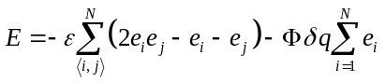 . (1)
The sum over ⟨i, j⟩ refers to interactions between particles i, configured as e_{i} = {0, 1}, and their nearest neighbors j. Adjacent particles with dissimilar e values increase E by an interaction energy ε. The second sum is the field term, in which particles transitioning from 0 to 1 decrease E by Φδq, each moving a small “gating” charge δq in the process, and −δq in reverse. In the absence of the applied field Φ, and assuming periodic boundary conditions, the internal energy of the system increases in increments of 2ε from 0 to 2Nε. The charge q, which, like E, serves as a collective variable in microcanonical space, is given by:
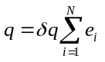. (2)
The value of q ranges from 0 to Nδq. The electrical Ising model is easily shown to be isomorphic with the traditional magnetic Ising model. Therefore all results discussed here are valid also for the traditional model.
We justify the choice of electric Ising model by analogy with ion channels, whose central ion-conducting pore units demonstrate weak voltage-sensing behavior even in the absence of canonical voltage sensors (ref). The mechanism for intrinsic pore voltage sensitivity is not known, but presumably it involves long-range correlations in the secondary structure that influence the pore selectivity region. Figure 1 shows how discrete conductance in a small “pore” region comprised of four selectivity particles appears as a two-state process when viewed on a macroscopic time scale. The so-called telegraph signal is qualitatively similar to actual single channel recordings, and, like actual channels, demonstrates voltage- and temperature-dependence. For the Ising model, we focus on “gating” charge q since, unlike the manufactured conductance g, q is a proper thermodynamic variable. We note however, that under two-state conditions, q and g yield practically identical macroscopic trajectories.
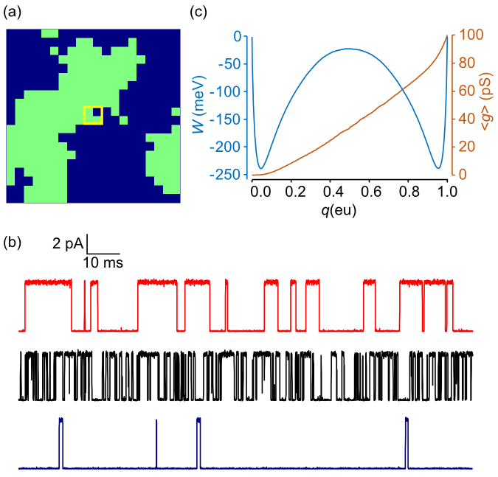
FIG. 1. (a) 20 x 20 electrical Ising model. Green cells indicate activated particles. In order to simulate an “ionic” current i(t) qualitatively similar to those observed in ion channels, we devised a central “pore” consisting of a 2 x 2 particle sub-grid (yellow square). The pore conductance g is the sum of fluctuating 25 pS conductances of the inscribed particles. (b) Continuous-time Monte Carlo simulations of the Ising model “pore” at two temperatures, with ionic current governed by Ohm’s law: i = g(V – V_{rev}). Simulation parameters for the top trace (red) adhered to standard conditions described in the text, with Φ_{rev} (reversal potential) = –60 mV. The current was digitally filtered as previously described (Sigg, 2013) with a cutoff frequency f_{c} = 10 kHz and sampling rate f_{s} = 100 kHz. In the middle black trace, T was increased from 17 °C to 27 °C, and in the lower blue trace, Φ was decreased from 0 mV to -100 mV. The observed fluctuations are entirely internal, with no external noise added. (c) 1D free energy landscape W(q) and mean conductance ⟨g(q)⟩ obtained by time-averaging a 0.4 sec unfiltered trajectory under standard conditions.
In order to study Ising dynamics we needed to define microscopic rate constants. These are constrained by detailed balance:
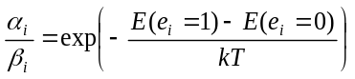, (3)
where α_{i} and β_{i} are the forward and backward rate constants associated with activation of the i^{th} particle. A variety of forms for α_{i} and β_{i} are compatible with Eq. 3. We chose formulas based on activated kinetics:
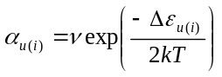, (4a)
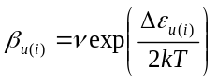 , (4b)
where the energy of activation Δε is linearly dependent on the number u of activated neighbor particles and the field strength as follows:
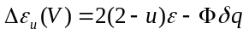. (5)
We chose the pre-exponential factor ν to be temperature-independent so that the T-dependence of the collective system dynamics can be attributed entirely to the inter-particle and field interactions described by Eq. 5.
There is nothing unique about our choice of microscopic rate constants. A different choice attributed to Glauber (ref) can used to prevent microscopic rates from exceeding ν, a useful property when performing kinetic Monte Carlo simulations with a fixed time step. We avoided undersampling error caused by a fixed time step by employing a continuous-time Monte Carlo algorithm popularized by Gillespie (ref).
We chose as reference model the 20 x 20 Ising grid (N = 400) with the following parameters: T = 22 °C; Φ = 0 mV; ε = 24 meV; q_{max} = 1 eu; and ν = 5 x 10⁴ kHz. These define “standard” conditions for this paper. Additional experiments with different T, V, and N were run to determine environmental and grid size effects on the forward rate constant. The values of ε, δq = q_{max}/N, and ν were held constant across all experiments except the temperature ramp in Fig. 3b, where ν = 10⁴ kHz.

- Mesoscopic states
A hierarchy of scales were used in this study. Each coarse-graining step led to a new master equation and set of rate constants. To avoid confusion, we assign specific names to successive spaces. The designation “Ising” refers to unbiased trajectories through 2^{N} trajectory space (x), with elementary rate constants {α_{u(i)}, β_{u(i)}} (Eq. 4). The “2D” model is the outcome of coarse-graining onto the (N +1)² microcanonical grid space (q, E), but represented in the Gibbs ensemble (N, T, Φ). The 2D rate constants are: {a_{kk′}, b_{kk′}}. The “1D” model is the projection of the 2D master equation onto the (N +1) reaction coordinate q with rate constants {a_{m}, b_{m}}. The 1D dynamics can be alternatively described by a quasi-continuous diffusion landscape {W(q), D(q)}. Finally, the phenomenological two-state model in the (N, T, Φ) ensemble is defined by forward and backward rate constants k₁₂ and k₂₁. The Ising model is considered “microscopic”. The 1D and 2D representations are “mesoscopic”, and the two-state model is “macroscopic”.
The coarse-graining process for mesoscopic states is illustrated in Fig. 2. There is a one-to-one pairing between a (q, E) state and its integer representation (m, n), where q = mδq and E = 2nε. When discussing mesostates, we alternate between use of discrete (m, n) and continuous (q, E) variables. Discrete dynamics are governed by a master equation, whereas the continuous case is handled by the Smoluchowski equation. The (m, n) values of a specific microconfiguration can be determined by inspection: m is the total number of activated particles and n equals 2m – b, where b is the number of shared borders between the m particles. The (m, n) states form a distorted triangle on the microcanonical grid. The distortion is a concavity at the base with height 2N^{½}ε. The concavity gives rise to the characteristic symmetry-breaking properties of the Ising model.
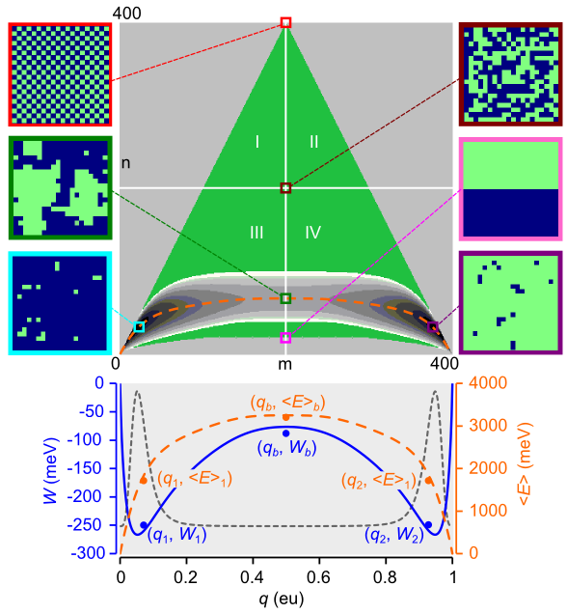
FIG. 2. Equilibrium course-graining of the 20 x 20 Ising system (N = 400). The central green triangle is the set of microcanonical mesostates on the (m, n) grid (73,448 states). It is separated into four quadrants (I to IV) based on external conditions. Positive β = (kT)⁻¹ and V favor the lower and right halves, respectively. The shaded contour map at the base of the triangle is the 2D free energy landscape (22,149 states) for standard conditions and W_{max} = 150 meV. The maximum vertical span (spatial bandwidth) of the landscape, located at the separatrix (m = 200), is 68 cells. The dashed orange line is the mean energy ⟨E⟩, which is also graphed in the lower plot. Representative microscopic configurations are shown within color-coded frames: maximum energy (red); maximum entropy (maroon); saddle point (green); minimum transition state energy (pink); and minimum free energy in metastable states 1 (aqua) and state 2 (purple). The saddle point configuration was chosen from an ensemble of unbiased reactive trajectories; it has a committor probability of 0.498 ± 0.005 based on 10⁴ test trajectories. The projected 1D free energy landscape W(q) is plotted below (blue line), accompanied by the equilibrium probability distribution (dotted gray line) and ⟨E⟩ (orange line). The filled circles accompanied by coordinates are the Boltzmann-averaged discrete positions of the two basin (1 and 2) and barrier (b) regions for W and ⟨E⟩.
For constant N, the density of states Ω(q, E) and the Gibbs free energy W(q, E, T, Φ) are related through the integer formula:
. (6)
Eq. 6 is the statistical equivalent to the thermodynamic relation W = E – TS – qΦ. For positive values of ε, only a frowny-face region of mesostates in the lower portion of the free energy triangle is appreciably populated. This corresponds to ferromagnetism in the traditional Ising model. Anti-ferromagnetism occurs for negative ε (or negative reciprocal temperature β), which populates the upper portion of the triangle where there is no symmetry breaking. In order to limit the accessible (m, n) states to a manageable number, we established a cut-off value W_{max} for the free energy. Projecting the 2D landscape W_{nm}(T, Φ) onto a 1D potential of mean force W(q, T, Φ), or its integer representation W_{m}(T, Φ), was performed according to:
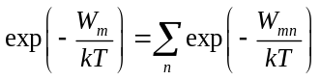. (7)
- Thermodynamics
The mesoscopic models faithfully preserved system thermodynamics (Fig. 3). From the 2D free energy landscape we calculated the environmental sensitivities of mean charge displacement ⟨q⟩ and the heat capacities C_{Φ} and C_{q}. The zero-field values of these quantities do not suffer from discontinuities at the critical temperature β_{c} = ln(1 + 2^{½})/ε experienced by the infinite-particle Onsager-Yang solutions. Quantities related to ⟨q⟩ were preserved by the 1D diffusion landscape, and even by the phenomenological two-state model.

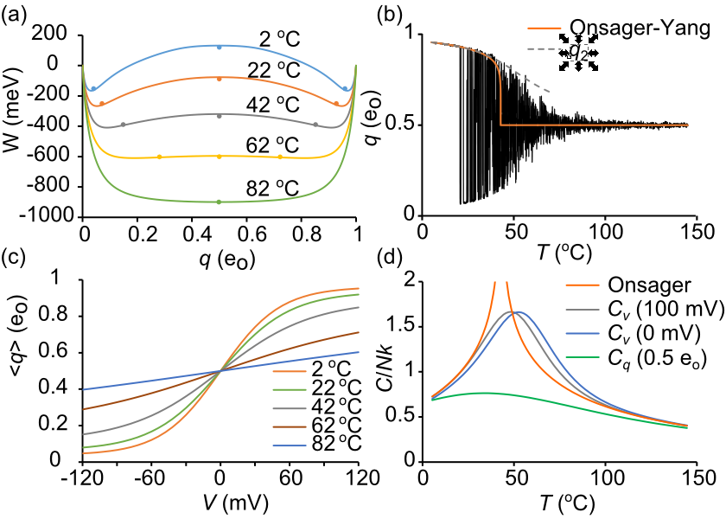
FIG. 3. Ising model thermodynamics. (a) W(q, T). Standard model at 22 °C. The transition from bistable to centrally stable landscape occurs at about 73 °C. The circles are Boltzmann-averaged coordinates for the metastable and barrier regions. (b) q(t) as continuous-time Monte Carlo simulation of 800 ms temperature ramp (ref) using standard conditions except ν = 10⁴ and linearly increasing T (5 °C to 145 °C). Filtering: f_{s} = 10 kHz, f_{c} = 1 kHz. The Onsager-Yang solution (ref) for infinite particles is superimposed. The dashed curve is q₂ determined from Boltzmann averaging. (c) ⟨q(Φ, T)⟩ computed from W(q, T, Φ). (d) Heat capacities derived from C/k = β ²⟨(ΔE)²⟩. The reference Onsager solution (ref) demonstrates critical discontinuity at 42.84 °C.
- Mesoscopic rate constants
We determined the 2D rate constants between states k = (m, n) and k′ = (m′, n′) in the (N, T, Φ) ensemble by computing the product of two numbers, the microscopic rate Eq. 4, which contains the T- and Φ-dependence, and a branching coefficient ⟨r_{kk′}⟩, which is the average number of transitions from each microstate in state k to available microstates in state k′. There are five possible mesoscopic rate constants in the forward direction, corresponding to the possible values of u (0…4):
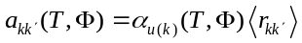, (8)
with five analogously-defined rate constants b_{kk′} in the backward direction, for a maximum of ten cardinal rates leaving each (m, n) state.
In the case of the smallest Ising model N = 2, the branching coefficients are integer numbers and coarse-graining is exact. With N = 4, 6, 8, … , there is inevitable loss of kinetic information, as demonstrated in detail in Fig. 4 for a representative transition. However, detailed balance, defined by Ω_{k} a_{kk′} = Ω_{k′} b_{k′k}, is preserved.
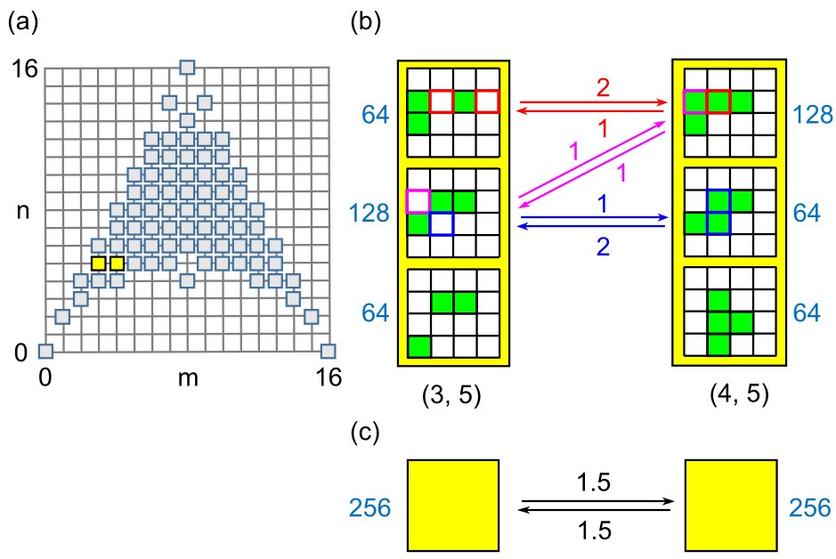
FIG. 4. (a) Microcanonical state space for the 4 x 4 Ising model. The (3, 5) and (4, 5) states are colored yellow. (b) Configurational sub-groups compatible with the (3, 5) and (4, 5) states. Green cells are activated. Each sub-group is labeled by its number of microstates (Ω_{i}). Allowed transitions between sub-groups are indicated by arrows color-coordinated to the initiating cell(s) and labeled by the local branching coefficient. (c) The coarse-grained (3, 5) → (4, 5) transition, demonstrating detailed balance between density of states Ω in blue and mean branching coefficients ⟨r⟩.
Metropolis Monte Carlo (MMC) was used to determine the 2D rate constants. Applying traditional MMC for β = 0, Φ = 0 allows every trial move to be accepted, in principle yielding the correct microcanonical ensemble and the branching coefficients. However, the large entropy gradient makes this algorithm impractical for all but the smallest systems, so a bias potential ω_{k} was applied to “flatten” the gradient and allow uniform sampling over all (m, n) states. The 1/t variant of the Wang-Landau algorithm with endpoint refinement parameter F_{final} = 10⁻⁶ was used to rapidly obtain an estimate for lnω_{k}. MMC was then implemented using the following procedure: choose a random particle for a trial flip, and after determining the locations on the (m, n) grid of the current state k and the trial state k′, choose a uniform random number 0 < r_{n} < 1 and apply the following acceptance criterion for the k → k′ transition:
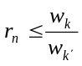, (9)
If Eq. 9 is satisfied, flip the particle. Time is incremented whether or not the trial is successful. For each discrete time point s, the ten cardinal rate constants a_{u} and b_{u} were summed from microscopic rates. For example, if twelve activated particles contribute to the backward transition (m, n) → (m – 1, n + 1) corresponding to u = 3 (see Fig. 5), the instantaneous rate b₃(s) is assigned the value 12β₃, where the branching coefficient is 12 and β₃ is the backward rate (Eqs. 4b). The other nine cardinal directions are also assigned their instantaneous rates. Particles were randomly assigned activation states to start each simulation. Following an equilibration period of 2 x 10⁶ time increments, time-averaged forward rates were obtained over the next 2 x 10¹⁰ increments using the following formula:
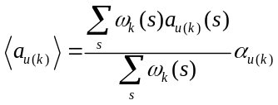, (10)
with the analogous expression for reverse rates ⟨b_{u(k)}⟩. The weighted sum preceding α_{u(k)} is the branching coefficient ⟨r_{kk′}⟩. The normalized microcanonical density of states was obtained from:
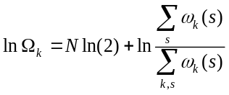. (11)
The density of states Ω_{k} and forward and reverse branching coefficients ⟨r_{u(k)}⟩_{a} and ⟨r_{u(k)}⟩_{b} were stored as N x N matrices lnΩ, A_{u}, and B_{u} (Fig. 5). These eleven matrices are not independent, as the entire group can theoretically be constructed from any three of its members, for example A₀, A₁, and A₃. The following relations apply {u = 0,…,4}:
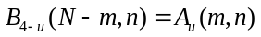 (12a)
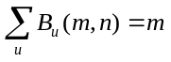 (12b)
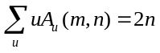 (12c)
(12d)
The first line expresses the mirror symmetry between A_{u} and B_{4-u}, which is intrinsic to the structure of the Ising model. The last line describes detailed balance between opposing branching matrices A_{u} and B_{u}. The middle lines were empirically found to be true.
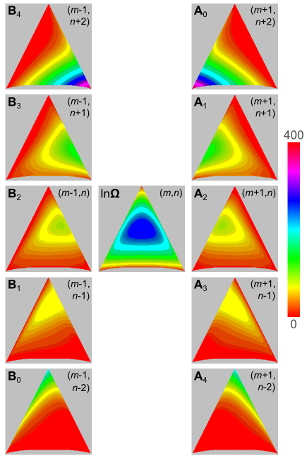
FIG. 5. Branching coefficients for the ten cardinal directions originating from the center square are stored in N x N matrices A_{u} and B_{u}. N = 400. The matrix shown in the center square is the density of states lnΩ.
The 1D rate constants a_{m} and b_{m} were obtained by projecting the 2D rate constants onto the q-axis through Boltzmann averaging in the (N, T, Φ) ensemble. In 1D, detailed balance assumes the form:
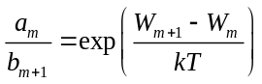. (13)
For small increments δq, the 1D master equation can be converted to a diffusion equation. The correspondence between {a_{m}, b_{m}} and the diffusive {W_{m}, D_{m}} arises from the Kramers-Moyal expansion of the master equation, from which the second coefficient yields the diffusion coefficient:
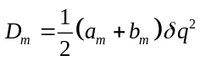. (14)
The free energy W_{m} is determined from the detailed balance condition (Eq. 13). The Smoluchowski equation describes 1D diffusion kinetics in continuous space:
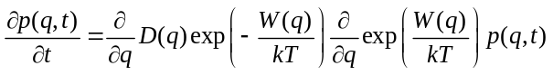, (15)
where p(q,t) is the probability distribution of charge displacement. Parallel methods exist for the master and Smoluchowski equations to compute macroscopic rates. In general we chose the discrete formulation, since approximating the master equation with a diffusion equation adds a potential source of error and, in any case, continuous equations need to be discretized for numerical solution; however, for system sizes used here, there was no significant difference in outcomes between the two equations.
III. THE MACROSCOPIC RATE CONSTANT
- The gold standard: dwell time analysis of Ising simulations
We needed a “true” value for the forward rate constant k₁₂ in order to gauge accuracy in coarse-graining. We obtained k₁₂ for varying values of N, T, and Φ from mean first passage times (mfpt) using simulated Ising dynamics. We considered only the forward rate k₁₂ since in zero-field conditions, the opposing rates k₁₂ and k₂₁ must be equal. In cases where Φ ≠ 0, the detailed balance equation easily yields the reverse rate. The phenomenological two-state equation predicts an exponential distribution of dwell times in the reactant state. The mean dwell time τ₁ is the inverse of the rate constant k₁₂. In a long, unbiased Ising trajectory with ~10⁴ forward barrier transitions, reactant state dwell times were obtained from first passage times, defined as the exact interval between first crossings of the reactant basin q₁ and product basin q₂. We employed a continuous-time kinetic Monte Carlo algorithm described by Gillespie (ref). Briefly, in each step, state-dependent flip rates (α_{i} or β_{i}) were determined for every particle i, and particle rates were summed in the forward (∑α_{i}) and backward (∑β_{i}) directions. The real-valued step time was randomly obtained from −lnr_{n}/(∑α_{i} + ∑β_{i}), and the particle to be flipped was chosen from a separate random draw using weights proportional to each particle’s activation or deactivation rates. The process was repeated until 4 seconds of simulation time was completed. The same algorithm was used to simulate coarse-grained 1D and 2D dynamics.
Differences in reactant state dwell times for Ising and coarse-grained model trajectories are visible by eye upon inspecting filtered q(t) trajectories (Fig. 8a, b). The reactant dwell time distributions from Ising, 1D, and 2D simulations underwent Sigworth-Sine transformation (ref). Practical features of the Sigworth-Sine plot are that they generating uniform residuals when fitting to the distribution curve, and that the transformed distribution peaks at τ₁.
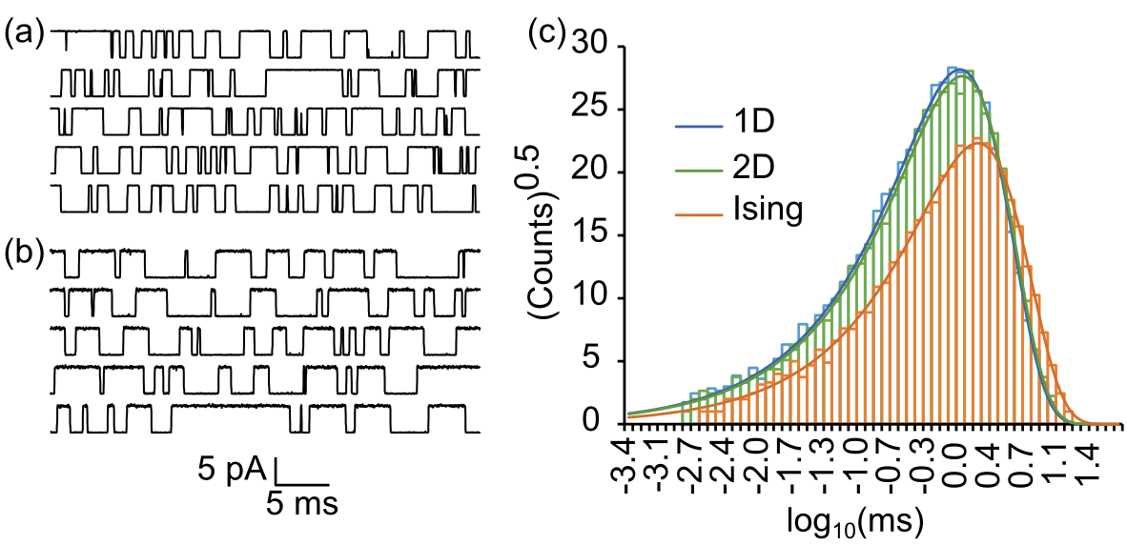
FIG. 6. Dwell time analysis. (a) Filtered “ionic” current trajectories simulated from the 1D master equation. (b) Same as (a) except with Ising dynamics. The standard model was used in both simulations; f_{c} = 10 kHz, f_{s} = 100 kHz. (c) Sigworth-Sine plot of binned passage times from q₁ to q₂ demonstrates overall fewer events and a longer average dwell time for Ising dynamics compared to the coarse-grained 1D and 2D dynamics.
It is apparent that in both Ising and coarse-grained models, the binned dwell times are exponentially distributed across nearly four orders of magnitude in time. Evidently, macroscopic kinetics is accurately described by the phenomenological two-state equation. Fits of the theoretical equation to the experimental dwell time distribution yielded a τ_{fit} that was very near to τ₁ despite error introduced by binning (Table I).

TABLE I. Reactant state dwell times for 4 s simulation (standard model).
 | Ising | 2D | 1D
events | 6,776 | 10,397 | 10,791
τ₁ (ms) | 1.672 ± 0.020ª | 1.145 ± 0.011ª | 1.086 ± 0.010ª
k₁₂ (kHz) | 0.5982 ± 0.0073^{b} | 0.8735 ± 0.0085^{b} | 0.9210 ± 0.0088^{b}
τ_{fit} (ms) | 1.675 | 1.146 | 1.088
ªs.e.(τ₁) = τ₁/events^{½}.
^{b}s.e.(k₁₂) = (k₁₂/τ₁)s.e.(τ₁).

The coarse-grained representations (1D and 2D) generated significantly smaller τ₁ values than the Ising model, resulting in a roughly 50% larger k₁₂ value. The 2D model was only marginally more accurate than the 1D model. Thus coarse-graining over the microcanonical ensemble, though it correctly retains equilibrium properties for all T and Φ, fails to predict the correct rate of macroscopic relaxation for the standard model (T = 22 °C, Φ = 0 mV).
- Numerically solving the master equation to obtain k₁₂
To confirm the dwell time results, numerical solutions of the master equation were used to compute k₁₂ for mesoscopic models. The master equation is described in matrix form by dp/dt = pA, where p(t) is the row vector of state probabilities and A is the matrix of rate constants with rows summing to zero. Note that some authors use a column-order format in which the rate constant for an i → j transition is a_{ji} rather than the row-order variable a_{ij} used here. In the case of the phenomenological two-state process, the matrix A is simply:
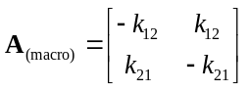. (16)
The first non-zero eigenvalue of A_{(macro)} is λ₁ = –(k₁₂ + k₂₁). In the absence of an applied field, we have k₁₂ = k₂₁, so each unidirectional rate constant equals –λ₁/2. However, knowing λ₁ fixes k₁₂ and k₂₁ regardless of field strength, since the ratio k₁₂/k₂₁ can be determined from detailed balance.
The rate matrices for the mesoscopic (1D, 2D) master equations are much larger than A_{(macro)}, requiring numerical solutions. In block form, A_{(meso)} looks like:
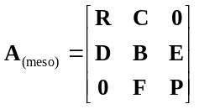, (17)
Where diagonal blocks R, B, and P represent the reactant, barrier, and product regions, separated on the charge axis by q₁ and q₂, and C, D, E, and F are the off-diagonal transition matrices. Although A is singular, R, B, and P can be inverted since they do not represent closed systems.
We used two methods to calculate k₁₂ from the mesoscopic master equations: (1) eigenvalue analysis and (2) mean first passage time analysis. The eigenvalue method equates the first non-zero eigenvalue λ₁ of A_{(meso)} to the expression –(k₁₂ + k₂₁), as in the macroscopic model. A large separation between λ₁ and higher eigenvalues implies a large time scale difference between inter- and intra-state events (Fig. 7a), an indicator of macroscopic Markovian dynamics (ref). The ratio λ₂/λ₁ was 1150 for the 2D model and 1260 for the 1D model.
The mfpt method involves truncating A_{(meso)} at q = q₂, thereby creating an invertible matrix R′ made up of the four block matrices in the left upper corner of A_{(meso)}. The mfpt for q to the left of the absorbing boundary at q₂ is obtained by solving
R′τ = −u, (18)
where τ is the column vector containing τ(q → q₂) and u is the unit vector. The quantity τ⁻¹(q₁→ q₂) is an accurate estimate of the forward rate constant k₁₂ for sufficiently large free energy barriers. The value of k₁₂ obtained this way is fairly insensitive to the choice of q₁ (Figure 7b), a reflection of Markovian dynamics. A related equation, also based on the Kolmogorov backward equation, is:
Bπ = −Eu, (19)
where π is the column vector of splitting or committor probabilities from positions within block B to q₂. From π, one can equate k₁₂ to the flux-over-probability expression J/P₁, where P₁ is the equilibrium probability of the reactant state and the flux J is evaluated for any dividing border Γ spanning the bottleneck region, as described by (Berezhkovskii et al., Metzner et al.):
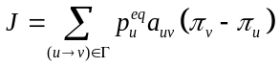. (20)
The mfpt and committor methods computed numerically identical values of k₁₂, underscoring the common origin of the two algorithms.
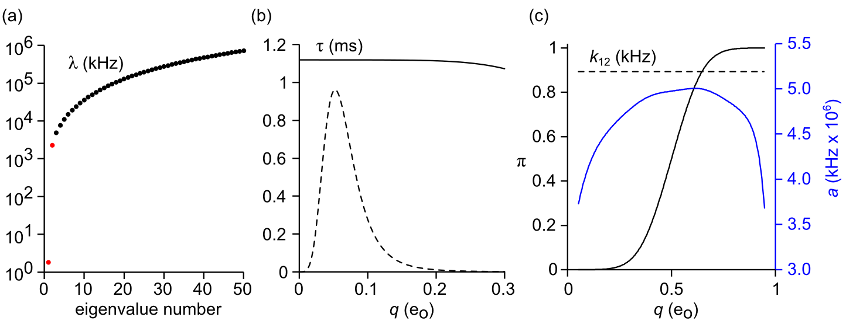
FIG. 7. Methods for calculating k₁₂ from the 1D master equation. 2D methods are analogous. (a) Eigenvalues. The first two non-zero eigenvalues are shown in red. (b) Mean first passage time. The value of τ(q) changes little across significant equilibrium probability density (dashed line) in the reactant basin. (c) Committor analysis. The committor probability π(q) is in black and the forward rate constant a(q) is in blue. The value of k₁₂ (dashed line) obtained from Eq. 20 is constant for the entire barrier region.
A practical difficulty arose from the large size of A_{(meso)}, particularly for the 2D representations. From the (N +1)² possible 2D states, somewhat less than half are theoretically accessible (Fig 2). In the case of the 20 x 20 Ising model, A_{(2D)} would be 73,448 x 73,448 if all possible transitions were included. The number of accessible states l was substantially reduced by implementing a free energy cutoff W_{max}. In order to avoid an artificial bottleneck, W_{max} was assigned a value at least 150 meV greater than the saddle point energy. Further size reductions in A_{(2D)} were achieved by repacking the matrix into band form. We numbered the mesostates in column order of increasing m and n(m). This resulted in a maximum spatial bandwidth d for the main diagonal that is equal to the width of the saddle point region. The banded A_{(2D)} dimensions were l x 2d+1. Typical values of l and d for the 2D landscape were ~20,000 and ~70. By taking advantage of eigenvalue and linear routines designed for symmetric band matrices, k₁₂ could be calculated in short order. The eigenvalue and mean first passage time calculations were easily adapted for 1D calculations, where A_{(1D)} is tridiagonal (d = 1) and l = N + 1.
The results tabulated in Table II are consistent with the 50% increase in the value of k₁₂ established in Table 1. There were some mild discrepancies in two circumstances where the free energy barrier exceeded 8 kT (T = 17 °C and N = 484). The dwell time rate constants for these taller barriers were slightly larger compared to the other two methods (for example, Fig 6b). However, even in these special cases, the Monte Carlo outliers were not enough to significantly alter the mean value of k₁₂ taken from all three methods. Despite the fact that numerical methods were in agreement, it was important to rule out subtle systemic biases that could cause an artefactual increase in the rate constant.
- k₁₂ as a function of N, T, and Φ
We compared the gold-standard value of k₁₂ against mesoscopic eigenvalue, dwell time, and mfpt predictions, reasoning that agreement between the three coarse-grained methods was a marker of numerical accuracy. This was done for a range of N, T, and Φ values consistent with the phenomenology of two-state kinetics. The dependence of k₁₂ on external variables be predicted from their respective influence on the 1D diffusion landscape. Reaction rate theory predicts that k₁₂ should decrease exponentially with forward barrier height ΔW = W_{b} – W₁ and increase linearly with D_{b}. In Figure 9, we see that ΔW increases roughly in proportion to N and inversely to T and Φ. The critical barrier value of the diffusion coefficient (D_{b}) increases substantially with rising N relative to change in ΔW, less dramatically with rising T, and is fairly insensitive to Φ.
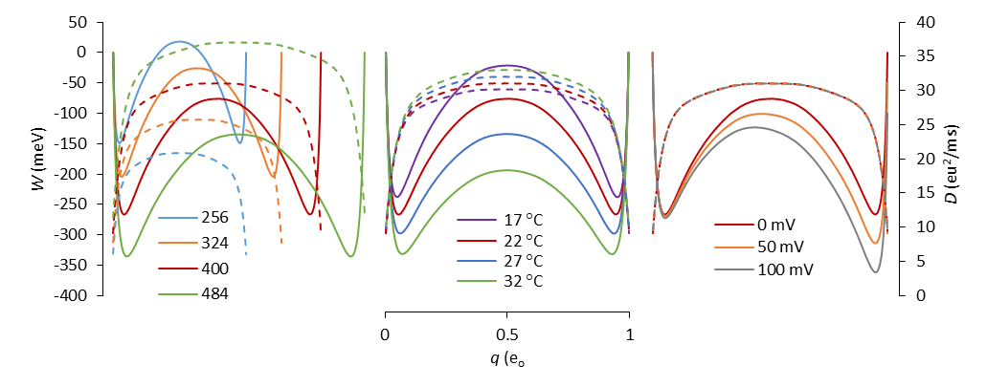
FIG. 8. Free energy (solid lines) and diffusion (dashed lines) landscapes as a function of model parameters (left plot, N; middle plot, T; right plot, Φ). The red curves correspond to the standard model. Landscapes were calculated from ensemble averaged mesoscopic rate constants, but nearly identical results were obtained by time averaging Monte Carlo trajectories.
We wanted to know if the 3:2 ratio between coarse-grained and gold standard values of k₁₂ was consistent across all environmental conditions. This proved roughly to be the case within the range of interest, with 1D rates again slightly larger than their 2D counterparts. Linear fits describing the relationships lnk₁₂ = cX + d, with X representing N, T, and Φ, resulted in nearly identical slopes c for the mesoscopic and gold standard data. These slopes have physical significance. From the lnk₁₂ vs. N plots one obtains the chemical potential of activation. Each added particle increases the free energy barrier by an average of 0.2 meV. The lnk₁₂ vs. T and lnk₁₂ vs. Φ plots are consistent with an activation charge q_{a} of 0.40 e_{o} and activation energy E_{a} of 1450 meV. The value of E_{a} is closely related to ΔE = ⟨E⟩_{b} – ⟨E⟩₁, determined from regional Boltzmann averaging of the mean energy landscape. Under standard conditions, ΔE = 1485 meV (Fig. 2). The magnitude of ΔE ≈ E_{a} is interesting from the standpoint of enzyme reactions, since it suggests why temperature studies can sometimes yield large activation energies (enthalpies) when calculated from an Arrhenius plot, yet the actual free energy barrier ΔW might be quite small (ref), as it is in our model. The difference in the two energies of course is accounted for by a large positive ΔS. We can similarly compare q_{a} with Δq = q_{b} – q₁, the latter computed as 0.43 e_{o} under standard conditions, but varies significantly with T (Fig. 3b).
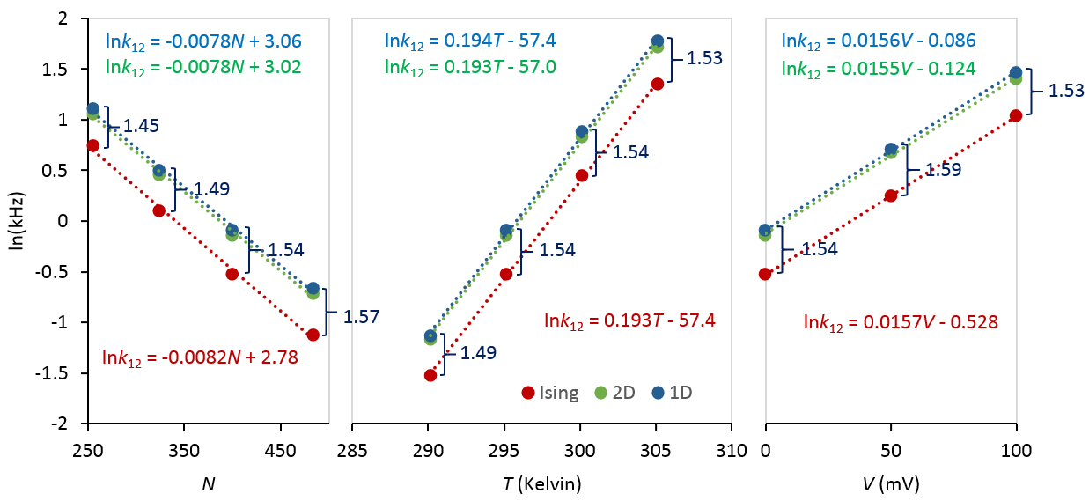
FIG. 9. Linear regression analysis of semi-log plot of k₁₂ with respect to same environmental conditions in Fig 9. The Ising rate constants were calculated as the inverse means of reactant state dwell times, as described in the text. The 1D and 2D rate constants were averaged from their respective dwell time, mfpt, and eigenvalue calculations. Error bars from averaging six experiments for each data point are not visible because they are located within the markers. The linear regression equations are color-matched to their respective fitted data. The ratios of 1D to Ising rates are written in blue.
- Error analysis
We identified two potential sources of error that might influence outcomes. The first is the choice of random number generator, which has led to erroneous conclusions in previous studies (ref). We tested several pseudorandom number generators to address the possibility of biased sampling: (1) Numerical Recipes© long-period L’Ecuyer generator with Bays-Durham shuffle (ran2) (ref); (2) Intel® MKL Library SIMD-oriented Fast Mersenne Twister (FMT) (ref); (3) Intel® MKL Library multiplicative congruential generator (MCG) (ref); and (4) Intel® MKL Library combined multiple recursive generator (MRG) (ref). Three of the four generators yielded similar results. The MCG algorithm exhibited greater variability and systemic biases compared to the other three (Fig. [..]), and is not recommended for use in our model. Most simulations employed the ran2 algorithm. In a small number of cases involving large barriers where the performance of the random number generator was in doubt, repeating the simulations using the FMT and MRG algorithms confirmed the results.
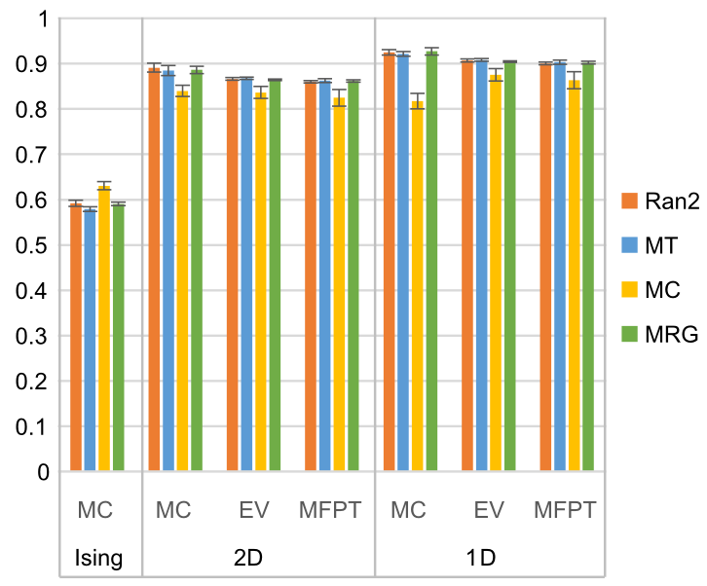
FIG. 10. Forward rate constant estimates (mean ± s.e., n = 6) from different methods (DT = dwell time, EV = eigenvalue analysis, MFPT = mean first passage time) as a function of pseudorandom number generator. Standard model. Results were consistent between generators except in the case of the multiplicative congruential generator (MCG), which demonstrated lower accuracy and precision compared to the other three generators.
The second source of possible error related to the coarse-graining of rate constants. Since branching coefficients were obtained from MMC simulations, there was unavoidable statistical error in their determination. Consider a pair of opposing mesoscopic rates a_{kk′} and b_{k′k} determined from MMC. The equilibrium probability distribution p_{k} is assumed known. In order to assure detailed balance, we applied the following balancing procedure:
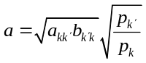, (21)
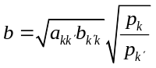, (22)
where a and b are the rate constants after balancing. For small relative errors in the unbalanced rates ε_{a} and ε_{b}, the relative error in each of the balanced rates is, to first order: (1 + ε_{a} + ε_{b})^{1/2} – 1. Thus there should not be any systemic bias in balanced rate constants if ε_{a} and ε_{b} are centered around zero. The value of k₁₂ rose 17% as a consequence of not balancing prior to dwell time analysis, but this dropped to a 6% increase when the unbalanced rates were drawn from an average of 30 experiments, thus lowering statistical error. The corresponding increase in 2D was only 4%, which paradoxically increased to 7% after rate constant averaging. Balancing had no measurable effect on mean first passage time calculations, but had a profound effect on 2D eigenvalue calculations, with a 10-fold increase in unbalanced k₁₂ estimates, though this was reduced to a 30% increase after rate constant averaging. The likely reason for the dramatic errors is that we used eigenvalue routines designed for symmetric matrices, and detailed balance needed to be satisfied in order to properly symmetrize the rate matrix (ref). There was no measurable error in 1D eigenvalues, as the process of coarse-graining from 2D to 1D ensured detailed balance. To summarize, unbalanced mesoscopic rate constants increased k₁₂ by a variable amount that in most cases was reduced by averaging rate matrices. We note that omitting the balancing process increased k₁₂ in the opposite direction from the gold standard value. That, and the observation that k₁₂ values derived from balanced rate matrices were consistent across all methods, suggests that balancing is an important component of coarse-graining and does not account for the 50% increase in k₁₂ derived from mesoscopic models.
- Rapid barrier methods for calculating k₁₂
For completeness sake, we include two additional methods that are of interest in large or complicated systems, where it is impractical to run long unbiased Monte Carlo simulations in the hopes of acquiring dynamic information about improbable reactive events. After employing umbrella sampling or similar methods to efficiently obtain the free energy landscape, simulations initiated from the transition state can be used to obtain the diffusion coefficient or calculate the reactive flux. These barrier methods occur on a rapid time scale much smaller than the typical reactant dwell time or mean first passage time. Their application rests on the fluctuation-dissipation theorem.
- Nyquist analysis
An alternative to the master equation in calculating the mfpt is to employ the 1D diffusion landscape {W(q), D(q)} in the form of the Smoluchowski equation (Eq. 15). Using a well-known double integral (ref), it is easy to calculate the mfpt from q₁ to q₂. One finds that, in the case of the Ising model, the mfpt is insensitive to the spatial variation of D(q), and largely depends on the barrier value D_{b}. This is because D(q) is relatively constant in the critical barrier region. Thus, we can use the following formula for k₁₂ attributed to Kramers (ref):
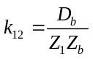 (23)
where Z₁ is the partition function ∫exp(−W(q)/kT)dq for the reactant state evaluated from q = 0 to q* = 0.5 e_{o}, where q* is the separatrix value of q, and Z_{b} is the partition function for the inverted barrier ∫exp(W(q)/kT)dq, evaluated from q₁ to q₂. In order to rapidly obtain D_{b}, we applied Nyquist’s current noise formula 4DB = ⟨i_{g}²⟩ to the “gating” current i_{g} = dq/dt, where B = 1.064f_{c} is the recording bandwidth (ref). B must be greater than the characteristic decay rate of the system (Fig 11a). Equilibrium currents and their fluctuations are centered at zero, which carries an advantage over measuring charge fluctuations, as ⟨(Δq)²⟩ increase as 2Dt and rapidly reach the boundaries of the barrier region. However, since transitions in the Ising model are discontinuous, careful attention must be paid to filtering and sampling i_{g} trajectories as previously described (ref). We expanded Nyquist’s theorem to two dimensions in order to simultaneously evaluate diffusion along charge and energy directions:
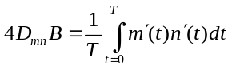, (24)
where D_{mn} is the discrete-variable diffusion matrix for the saddle point region of the 2D free energy landscape. The desired charge component is obtained from: D_{q} = D_{mm}δq². Confining the simulations to a window region defined by q = {0.35 e_{o} to 0.65 e_{o}}, we obtained D_{q} = 29.5 e_{o}²/ms [averaged from 6 x 500 trajectories of 1.6 μs duration]. The results for k₁₂ using Eq. 23 are found in table II. The diffusion matrix is:
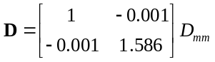. (25)
It is seen the energy diffusion coefficient D_{nn} is ~60% larger than its charge counterpart D_{mm}. This rules out diffusion anisotropy (ref) as contributing to the discrepancy between gold standard and coarse-grained values of k₁₂. In order to demonstrate the difference in time scales between E- and q-relaxation we observed the average decay of E(t) and q(t) from the random spin state located in the vicinity of (m, n) = (N/2, N/2) to one of the two stable states. E-relaxation occurs with an initial fast decay with time constant (19.5 ns) reflecting rapid equilibration at the saddle point, followed by a slower (745 ns) decay as the system relaxes to one of the stable states (Fig. [..]). The slower decay is consistent with the single time constant of q-relaxation (761 ns).
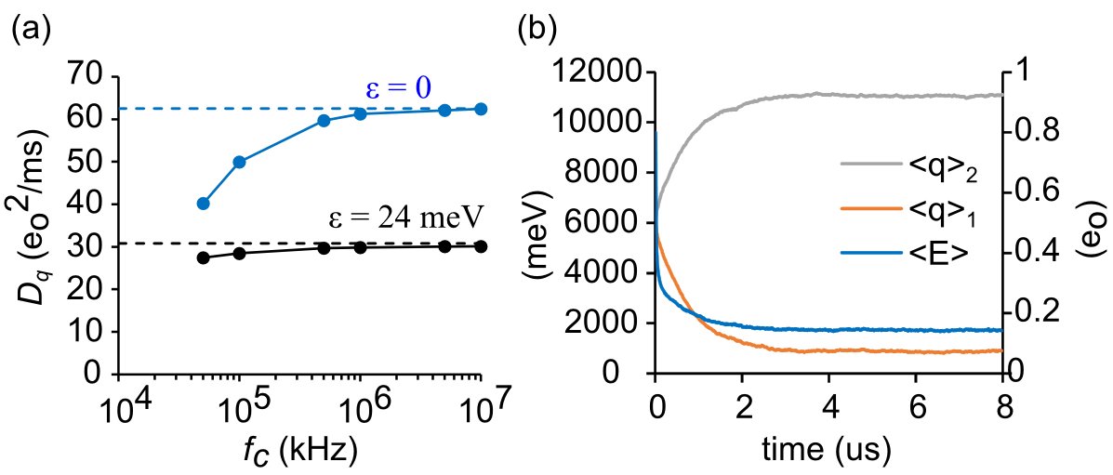
FIG. 11. Diffusion coefficients. (a) Evaluating D_{q} as a function of filter cut-off frequency. The data in black was obtained under standard conditions, with the peak value of D(q) shown as reference (dashed line). The data in blue corresponds to independent particles (ε = 0), where the reference value D_{q} = 0.5(N + 1)νδq² is known exactly.
- Reactive flux calculations
The reactive flux method originated with molecular dynamics simulations (ref) but has been expanded to discrete state models (ref). It distinguishes between reactive trajectories with initially positive and negative velocities starting from the barrier separatrix, and records the fractional appearances on the product side. At time zero, only positive velocities are counted, so the initial reactive flux f(0) equals the rate constant from transition state theory (TST). However, due to recrossings of the barrier by both initial positive and negative velocity trajectories, f(t) rapidly decays to a plateau value after a time T required for the system to decay to one of the stable states. After a very long time, on the order of λ₁, f(t) vanishes completely due to large-scale barrier recrossings. The ratio f(T)/f(0) is known as the transmission coefficient κ. We can estimate κ as the ratio of k₁₂ to the TST rate constant given by p*a*/2p₁, where p* is the equilibrium probability of the separatrix state, and p₁ = 0.5 is the equilibrium probability of the reactant state. This approximation, using the gold standard value of k₁₂, yields κ = 0.011. This is a very small number, suggesting that a rather large number of reactive trajectories is needed to obtain good statistics.
A formulation of the reactive flux method applicable to the kinetic Ising model, formally defined as a continuous-time Markov jump process (ref), is as follows:
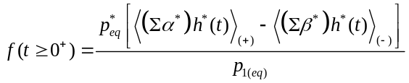 (26)
where Σα*(0) and Σβ*(0) are summed microscopic forward and backward rates taken at time zero, at the moment where the system trajectory lands on the separatrix after a brief equilibration time, and h*(t) is the Helmholtz function: h(q(t) – q*) = 1 if q(t) ≥ q*, else 0. The subscripts (+) and (−) refer to the ensemble of initial forward and backward trajectories. The (+) ensemble reduces to the TST result for t = 0⁺. Applying absorbing boundaries at q₁ and q₂, Eq. 26 approaches at long times:
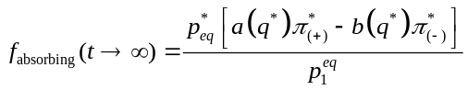, (27)
which is to be compared to Eq. 20.
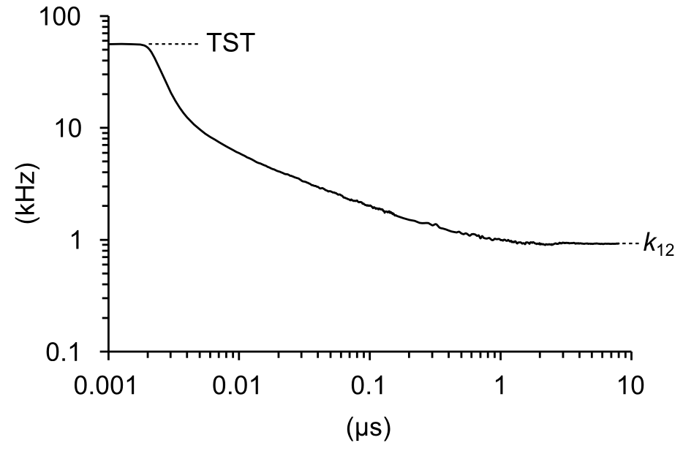
FIG. 12. Reactive flux in the standard model. Six experiments of 2 x 10⁵ traces each were obtained after an 800 ns constrained equilibration phase culminating with the crossing of the separatrix, followed by an 8 μs test run. The TST rate was 55.8 kHz. The k₁₂ value determined from an average of the last 3 μs was 0.92 kHz, corresponding to a transmission coefficient of 0.016.
- Committor functions and Markovianity
The optimal reaction coordinate in configuration space is the committor probability π(x) (ref). The committor-based diffusion landscape {W(π), D(π)} should yield the correct value of k₁₂, but constructing the committor landscape is technically difficult because x is intractably large. Extracting the coarse-grained committors π(q) and π(q, E) by solving Eq. 19 is straightforward (Fig. [..]a,b), but, as stated earlier, computing k₁₂ from these coarse-grained committors using Eq. 20 yields results identical to the mfpt method. This implies that coarse-graining distorts the committor function. We tested this by sampling π(x) along the free energy separatrix q = q* under standard conditions. For reasons of symmetry, π(q*) = 0.5. If sampled π(x) values on the separatrix differ substantially from π(q*), referred to as absence of dynamical self-consistency (ref: Peters et al., 2013), then projecting configuration space onto 2D space is associated with loss of dynamic information. This proved to be the case (Fig. [..]c), suggesting the coarse-graining process ignores important memory effects. Another way to view this result is that the inability of a given mesostate to predict the committor probabilities of its sub-constituent microstates fundamentally violates the Markovianity condition.
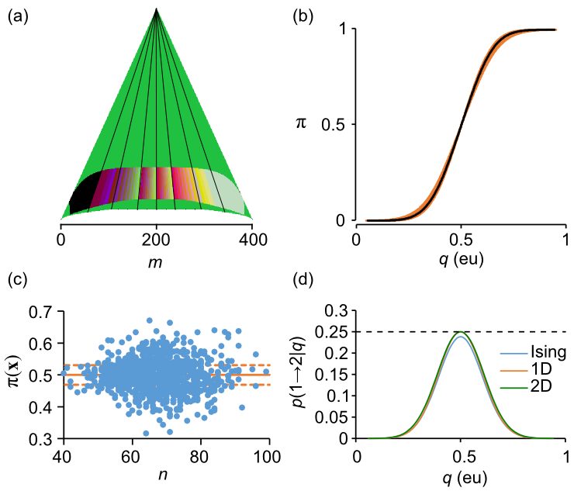
FIG. 13. Committor and Markovianity analysis. (a) Committor probabilities calculated from 2D master equation with W_{max} = 150 meV cut-off. Shading emphasizes isocommittor lines, which when extended to higher energies pass through the vertex of (q, E) states. (b) 2D isocommittor probability (orange) projected onto the q-axis, with 1D isocommittor probability (black line) superimposed. (c) Committor probabilities of microconfigurations harvested from the separatrix, evaluated from 10³ test runs. The dashed lines demonstrate the 95% confidence interval for a random coin flip. The large number of data points outside this interval points to the absence of dynamical self-consistency. (d) Markovianity analysis demonstrating memory effects in Ising kinetics projected onto 1D.
A simple test for Markovianity was recently introduced (ref). It involves evaluating probabilities of the kind p(a → b | q) for trajectories that begin at q_{a} and are absorbed by q_{b}, crossing q at some intermediate time. Using the basin coordinates q₁ and q₂ as our endpoints, we evaluated p(1 → 1| q), p(1 → 2 | q), p(2 → 1 | q), and p(2 → 2 | q) for a single unbiased trajectory containing 2,500 (1 → 2) reactions. We recorded event tallies for all q spanning the interval q₁ to q₂. Although p(…| q) are correlated between neighboring q, running the simulation multiple times (n = 14) yielded good statistics for the entire curve. The Markovianity condition requires p(1 → 2 | q)_{max} = 0.25, which under standard conditions occurs at q = q*. A smaller peak value implies memory effects, and a larger value is consistent with ballistic dynamics. Our model should only demonstrate memory effects, since x(t) is Markovian in coordinate space, and the coarse-grained representations are also Markovian. We simulated Ising, 1D, and 2D trajectories. The 1D trajectory is a control, since it is projected onto its own space. Both 1D and 2D peak values were statistically indistinguishable from the critical 0.25 value (1D: 0.2499 ± 0.0006; 2D: 0.2497 ± 0.0008), but the Ising trajectory peaked at a lower value of 0.2381 ± 0.0004. The 4.8% reduction from the Markov prediction is small, but it may account for the overestimation in coarse-grained calculations of k₁₂. A bonus feature of the Markovianity test is that the tallied event numbers could be used to generate committor probabilities, since π(q) = p(1 → 2 | q) + p(2 → 2 | q). From these simulation-based committor probabilities, we calculated k₁₂ through the use of Eq. 20 (Table II).
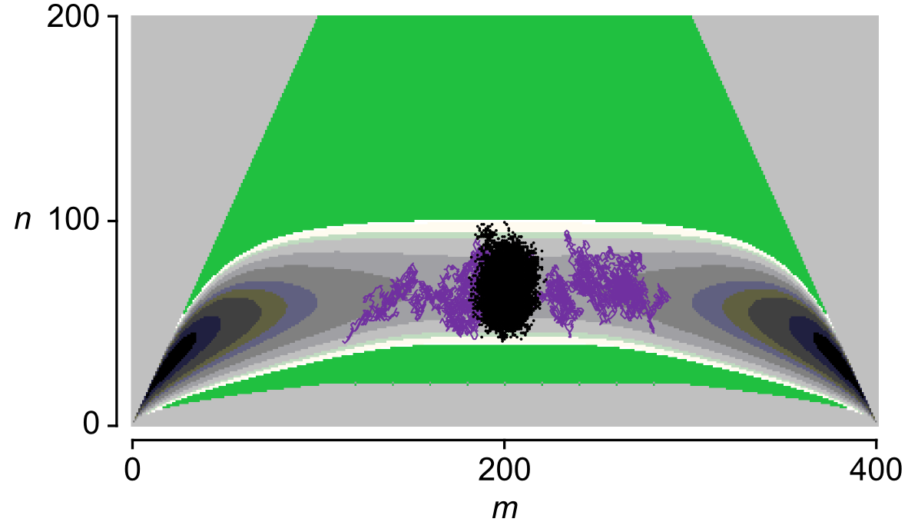
FIG. 14. Distribution of microconfigurations with committor probabilities in the 95% confidence range 0.469 to 0.532 (black dots) for an ensemble of unbiased reactive trajectories. A typical crossing trajectory with 8,511 steps is shown in purple.
We considered the possibility that an unknown collective variable critical to reactive dynamics was poorly represented in (q, E) space. To test this we harvested 34 unbiased reactive trajectories starting at q₁ and ending at q₂. The trajectories ranged from 3,029 to 21,595 Monte Carlo steps. Using the method described in Pan and Chandler (ref), we tested each configuration for the condition π(x) = 0.5, using a final run of 1,000 steps to narrow the 95% confidence interval from 0.469 to 0.532. The 14,837 isocommittor configurations mined in this fashion were projected onto the (q, E) free energy surface, as shown in Fig. 14. They clustered fairly uniformly around the saddle point region. The absence of bimodal distributions in Fig. 13c and Fig. 14 suggests that if there is a critical third collective variable, for example describing the disk-to-slab transition in a larger and colder Ising system (ref: Moritz et al., 2017), then it does not reveal itself in committor analysis near the separatrix of our model.

V. DISCUSSION
In this study, we computed the forward transition k₁₂ of the kinetic Ising problem in multiple ways. We can group the methods in terms of process. Only one method, dwell time analysis of the Ising process, can be viewed as a pure configurational process (x), analogous to what one would measure experimentally; therefore this was considered the gold standard value of k₁₂. Other methods involved some degree of coarse-graining on the microcanonical plane, either an x-process projected onto q such as Nyquist analysis or the reactive flux technique, or methods that originated with the 2D (q, E) or 1D (q) mesoscopic models. The values of k₁₂ from all methods under standard conditions are shown in Table II. We point out that the committor values originated not directly from the master equations using Eq. 19, but from the Markovianity experiments, as the former yielded practically identical results to the mfpt method.

TABLE II. Summary of k₁₂ averaged from 6 experiments (standard model).
Method | Process | k₁₂ (kHz) | standard error
Dwell time (Ising) | x | 0.59159 | 0.006895
Dwell time(2D) | (q, E) | 0.891089 | 0.009467
Dwell time (1D) | q | 0.92513 | 0.005992
eigenvalue (2D) | (q, E) | 0.866373 | 0.003352
eigenvalue (1D) | q | 0.906609 | 0.003512
mfpt (2D) | (q, E) | 0.859934 | 0.002575
mfpt (1D) | q | 0.90043 | 0.002721
Nyquist (Ising) | q(x) | 0.892715 | 0.003941
reactive flux (Ising) | q(x) | 0.921411 | 0.073493
1D committor (Ising) | q(x) | 0.907928 | 0.000948
1D committor (2D) | q(q, E) | 0.886759 | 0.000979
1D committor (1D) | q(q) | 0.903906 | 0.000579

The k₁₂ value for the gold standard method 0.592 ± 0.007 compared to 0.896 ± 0.007 for the average of the other eleven processes. The average coarse-grained processes overestimated the gold standard result by a ratio of 1.51 ± 0.02. This ratio was fairly constant across constraints that were consistent with a two-state process. Committor and Markovianity analysis suggested there was loss of system memory after projecting Ising kinetics onto the 2D plane, but very little information loss when projecting the 2D plane onto the 1D reaction pathway.
Our methods did not reveal the precise source of coarse-graining error, but a clue may be found by deconstructing a single transition into its micro-configurational states (Fig. 4). The same-energy (3, 5) to (4, 5) transition for the N = 16 system consists of microtransitions between configurational subsets, one of which in each state does not participate at all in the transition. Should the system find itself in one of the microstates of this non-reacting group, a transition must use a path to a higher or lower energy state. This suggests that for the Ising model, there are fewer trajectory pathways available than predicted by the coarse-grained representation. We conjecture that rate constant averaging over the microcanonical grid does not properly account for the smaller number of possible trajectories, and thereby overestimates the true rates.
Our intent in using microcanonical variables E and q as collective variables is that the density of states Ω and the branching coefficients ⟨r⟩ provide kinetic solutions for any value of T and Φ, albeit with a certain amount of coarse-graining error. This is valid for any range in (T, Φ), but we are most interested in a fairly narrow range in conditions consistent with two-state behavior on the millisecond time scale. The forward rate constant k₁₂ may be generally written:
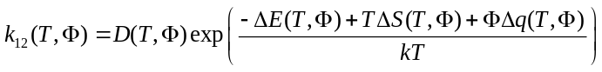, (28)
where ΔX = X_{b} – X₁ is the difference between Boltzmann-averaged barrier and reactant values of an extensive variable X. Eq. 28 is derived from Eq. 23 (ref). In order to use Eq. 28 to predict k₁₂(T, Φ) from a single set of conditions evaluating D, ΔE, ΔS, and Δq, then these quantities must be T- and Φ-independent. This requirement is not generally met, and specifically not in the system studied here (include a separate figure?). It may prove worthwhile to see if the microcanonical approach to coarse-graining can be implemented in continuous-state systems.

